**Soviet Support Ships**

The ships listed here are a representation of the more important support ships operated by the Soviet Navy in Northern Fury. Additionally, there are literally hundreds of smaller tenders, barges, service ships and tugs which are not shown. Many ships are simply listed by their Project number – a catalogue of ships can be found [here](http://russianships.info/eng/support/) but there are gaps even in this extensive listing.

[**Mikhail Kalinin-class passenger ship**](https://en.wikipedia.org/wiki/Mikhail_Kalinin-class_passenger_ship#Ocean_liners/cruise_ships_of_the_project_101/Seefa_340): There are 14 of the original 19 project 101 small passenger liners still in service and are used to move troops around the USSR and the world when needed. Each has the capacity for 333 passengers, but are not meant for amphibious operations, although they could be used for follow up forces.

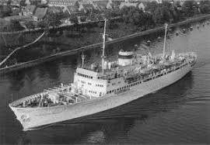

[**Altay Class Medium Tanker**](https://en.wikipedia.org/wiki/Altay-class_oiler): Only six ships of the Project 160 class were procured for the Soviet Navy, but some 60 were built for the merchant fleet and can be absorbed into the military if needed. By NATO standards these are small tankers but they can conduct Replenishment at Sea (RAS) with one ship at a time either over the side or from the stern.

|  |  |  |  |
| --- | --- | --- | --- |
| Class | Name | Fleet | Status |
| Altay | Kola | Northern |  |
|  | Elnya | Black Sea |  |
|  | Egorlyk | Pacific |  |
|  | Izhora | Pacific |  |
|  | Prut | Northern |  |
|  | Ilim | Pacific |  |

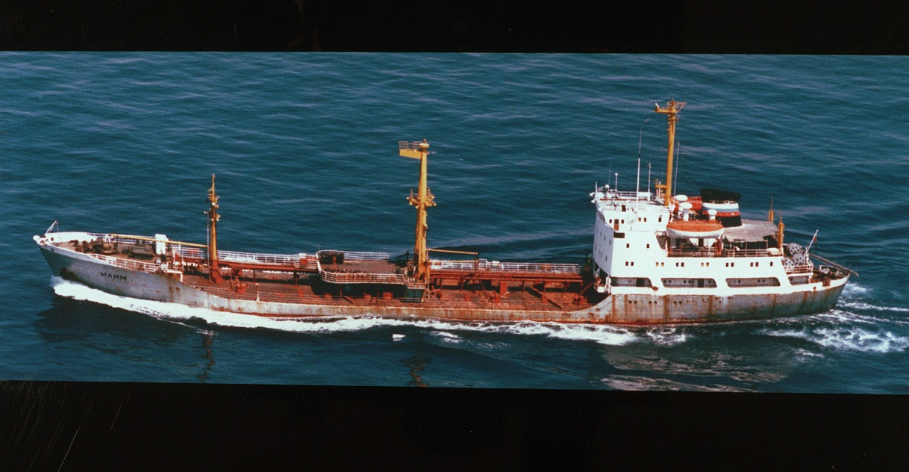

**Project 119**: Degaussing ships – 17 built

**Project 229**: Small dry cargo transport – 770 tons – 26 built

**Project 232**: Medium dry cargo transport – 2800 tons – 3 built (Anabar, Araks, Vitim)

**Project 233 & 233K**: Large dry cargo transport: Pr233K - 6700 tons (2) - (Megra, Svanetiya): Pr233 - 5,200 tons (8) – 10 built – (Atrek, Arat, BRN-76 to BRN-81)

**Lama Class** Tenders: The 7 units of this class (multiple project numbers) serve several functions such as ‘Floating Missile Technical Base’ (Pr 323, 323A), ‘Ballistic Missile Transport’ (Pr 323B), ‘Floating Base’ (Pr 1798), ‘Cruise missile Transport’ (Pr 2001) and ‘Ammunition Transport’ (Pr 323V)

|  |  |  |  |
| --- | --- | --- | --- |
| Class | Name | Fleet | Status |
| Pr 1798 | PRTB-13 | Black Sea | Floating Base |
| Pr 323, 323A | PRTB-15 | Northern | Missile Technical Base |
| Pr 323, 323A | PRTB-20 | Pacific | Missile Technical Base |
| Pr 323V | PRTB-26 | Northern | Ammunition Tpt |
| Pr 2001 | PRTB-33 | Black Sea | Cruise missile Tpt |
| Pr 323, 323A | General Ryabikov | Black Sea | Missile Technical Base |
| Pr 323B | PRTB-43 | Pacific | Ballistic Missile Tpt |

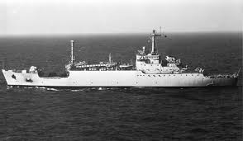

[**Khobi Class Tanker**](https://en.wikipedia.org/wiki/Khobi-class_tanker): The Soviet Navy operated 20 of these Project 437N small tankers built in the 1950’s until two were exported to Albania and another to Indonesia while two more was paid off. The remaining 15 are able to refuel one other ship at a time but not at sea.

|  |  |  |  |
| --- | --- | --- | --- |
| Class | Name | Fleet | Status |
| Khobi | Alazan | Northern |  |
|  | Tartu |  | Scrapped 1970 |
|  | Goryn` |  | Scrapped 1974 |
|  | Khobi | Black Sea |  |
|  | Sosyva | Baltic |  |
|  | Orsha | Baltic |  |
|  | Titan | Northern |  |
|  | Tunguska | Pacific |  |
|  | Sunta |  | To Indonesia 1959 |
|  | Linda | Black Sea |  |
|  | Indiga | Black Sea |  |
|  | Moksha | Pacific |  |
|  | Sysola | Northern |  |
|  | Cheremshan | Northern |  |
|  | Lovat` | Baltic |  |
|  | Shacha | Northern |  |
|  | Seyma | Black Sea |  |
|  | Shelon` | Pacific |  |
|  | Linda |  | To Albania 1958 |
|  | Semani |  | To Albania 1959 |

**Project 550**: Large dry cargo transport: 14,000 tons – 1 built (Yauza)

**Voda Class**: Project 561: Water Tanker: 2100 tons – 11 built (Vodoley 3, 9, 10, 12, 16, 17, 21, Abakan, Sura,MVT 6, 10, 18-20, 138, 428)

**Kazbek Class Tanker**: Four of these large – 16250 ton – tankers are operational. Because of their age, they likely have the same replenishment equipment as the Altay class; able to refuel one ship at a time over the side or from astern.

|  |  |  |  |
| --- | --- | --- | --- |
| Class | Name | Fleet | Status |
| Kazbek | Volkhov | Northern |  |
|  | Alatyr` | Pacific |  |
|  | Desna | Black Sea |  |
|  | SKh-334 | Black Sea |  |

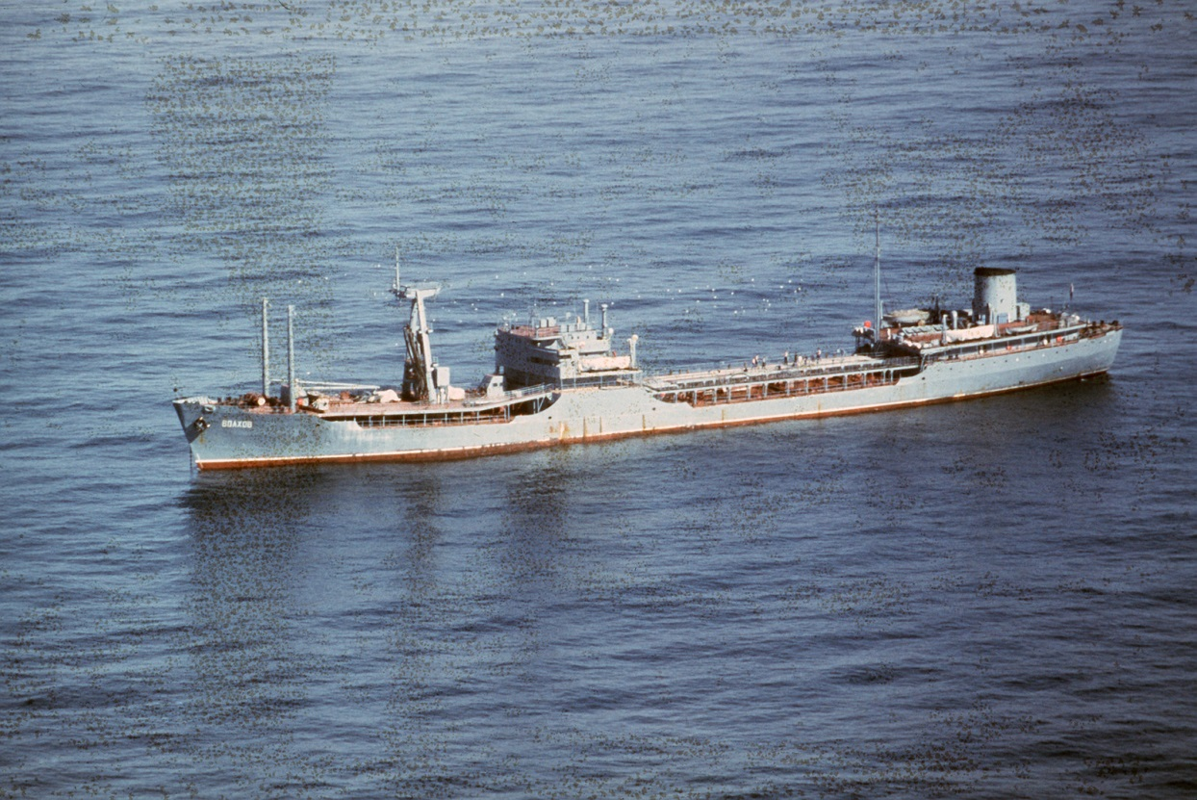

**Project 567K**: Large dry cargo transport – 22,250 tons – 3 built (Samara, Kandalaksha, Kolkhida)

**MS-6 Class**: Project 572, Medium dry cargo transport – 2,000 tons – 7 built (Irgiz, Khoper, Ilet’, Vologda, Araks, Bureya, Bira)

[**Uda Class Medium Tanker**](https://en.wikipedia.org/wiki/Uda-class_oiler): A more modern design of tanker, these ships can conduct RAS off both sides at once similar to American or British ships, they can also replenish ships over the stern. There are 9 of these Project 577 class ships in operation.

|  |  |  |  |
| --- | --- | --- | --- |
| Class | Name | Fleet | Status |
| Uda | Terek | Northern |  |
|  | Sheksna | Baltic |  |
|  | Don | Baltic |  |
|  | Donets | Northern |  |
|  | Dnepr | Baltic |  |
|  | Dunay | Pacific |  |
|  | Koyda | Black Sea |  |
|  | Lena | Baltic |  |
|  | Vishera | Pacific |  |

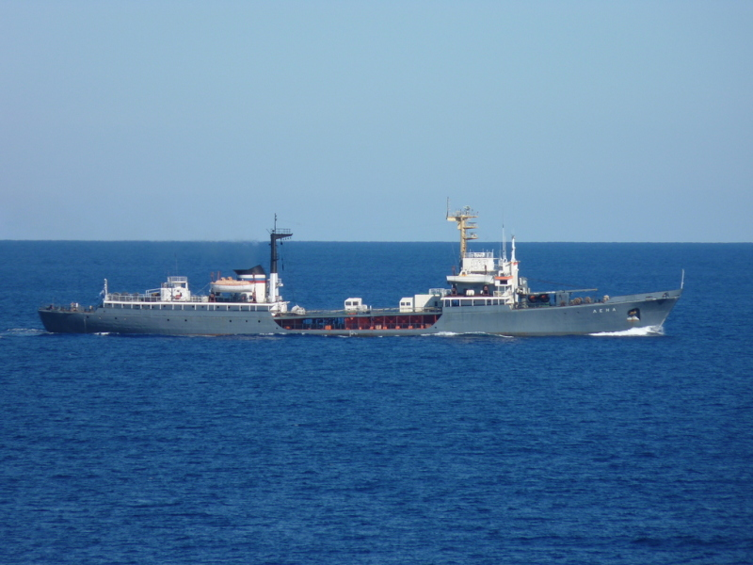

[**Telnovsk Class**](http://www.wesworld.jk-clan.de/index.php?page=Thread&threadID=10573): Medium dry cargo transport, Project 650. Built in Bulgaria there were 19 ships built, two were scrapped, one was sunk and used as the base of a pier on Shikotan Island and another was sunk for the filming of a movie. Ten were converted for Hydrographic survey (one scrapped and another re-converted); two were converted to cable laying ships (one scrapped one remaining), one was converted for nuclear transport, another for Hydroacoustics research, and one was re-converted to a diver support ship. The four remaining are in service to supply garrisons and ships abroad.

|  |  |  |  |
| --- | --- | --- | --- |
| Class | Name | Fleet | Status |
| Telnovsk | OS-21 | Black Sea | Hydroacoustics research |
|  | Ulyana Gromova | Pacific | Hydrographic survey |
|  | Oleg Koshevoy | Pacific | Hydrographic survey |
|  | Ishim |  | Sunk for Pier 1983 |
|  | Sirena | Northern | Hydrographic survey |
|  | Stvor | Baltic | Diver support ship |
|  | Gidrostat | Pacific | Hydrographic survey |
|  | Lot |  | Scrapped 1985 |
|  | Sviyaga | Black Sea |  |
|  | Aytodor | Black Sea | Hydrographic survey |
|  | GS-6 | Pacific | Hydrographic survey |
|  | VTR-72 | Northern |  |
|  | VTR-73 | Northern |  |
|  | VTR-74 | Northern |  |
|  | VTR-75 |  | Sunk for movie 1989 |
|  | VTR-143 | Northern | Nuclear transport |
|  | Lag | Northern | Hydrographic survey |
|  | Burevestnik |  | Cable/Scrapped 1986 |
|  | Manometr | Northern | Hydrographic survey |
|  | Umba | Pacific | Cable Ship |

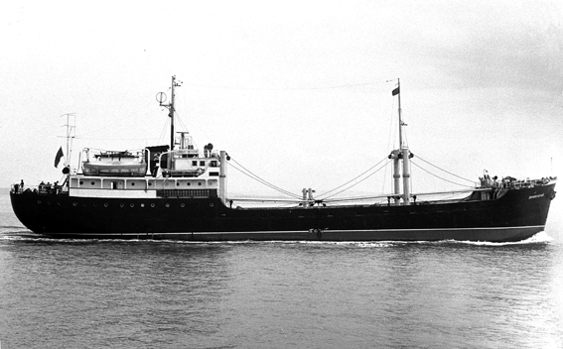

**Kaliningradneft Class**, Project REF-675: - 8,900 tons, 2 built (Argun, Vyazma)

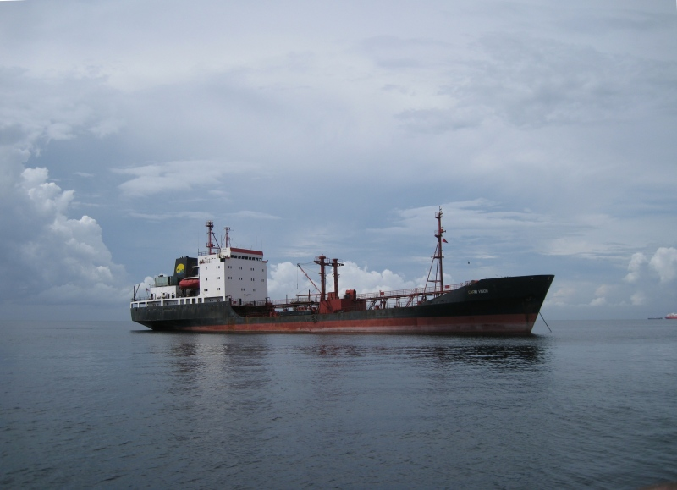

**Project 725**: Floating workshop – 4,700 Ton, 5 Built. (PM-17, 22, 30, 130, 135)

**Project 740**: Medium dry cargo Transport – 4,000 tons, 4 built (Turgay, Ufa, Pechora, Pinega)

**Nercha Class**, Project 931: Medium Tanker – 2,000 tons, 3 built (Klyazma, Nercha, Nara)

**Mod Andizhan Class**, Project 964: Large dry cargo Transport – 6,650 tons, 4 built, 1 Sunk (Vilyuy, Onda, ~~Posyet~~, Venta)

**Luza Class**, Project 1541: Small tanker – 1,500 tons, 9 built, 1 sunk, 1 scrapped, (Kama, Oka (sunk), Enisey (Scrapped), Don, Alambay, Aragvi, Barguzin, Selenga)

**Manych Class**, Project 1549: Water Transport – 5,900 tons, 2 built (Manych, Tagil)

**Boris Chilikin Class**: Fleet Replenishment Oilers (AOR), these six Project 1559 ships come very close to their western equivalents in being able to replenish large ships at sea. They carry bunker fuel for ships, diesel, aviation fuel, water, refrigerated goods and dry goods.

|  |  |  |  |
| --- | --- | --- | --- |
| Class | Name | Fleet | Status |
| Boris Chilikin | Boris Chilikin | Black Sea Fleet |  |
|  | Vladimir Kolechitskiy | Pacific Fleet |  |
|  | Dnestr | Northern Fleet |  |
|  | Ivan Bubnov | Black Sea Fleet |  |
|  | Genrikh Gasanov | Northern Fleet |  |
|  | Boris Butoma | Pacific Fleet |  |

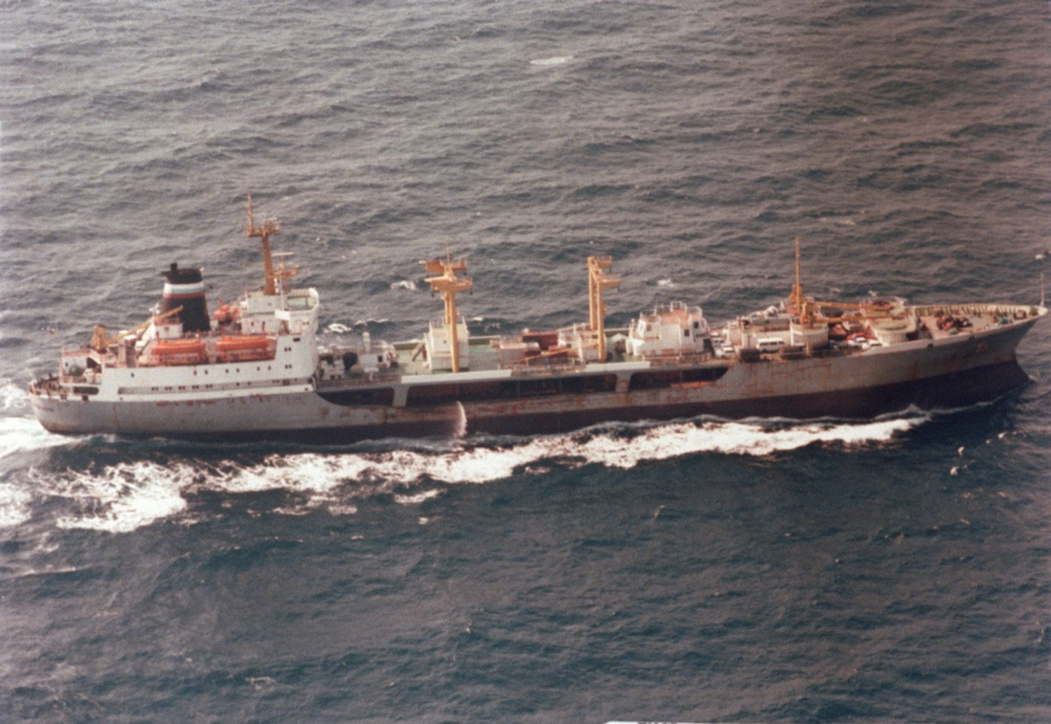

**Dubna Class**: Replenishment Tankers – 12,900 tons. Converted from civilian tankers these four ships can refuel from either side simultaneously or astern.

|  |  |  |  |
| --- | --- | --- | --- |
| Class | Name | Fleet | Status |
| Dubna | Dubna | Northern Fleet |  |
|  | Irkut | Pacific Fleet |  |
|  | Pechenga | Pacific Fleet |  |
|  | Sventa | Black Sea Fleet |  |

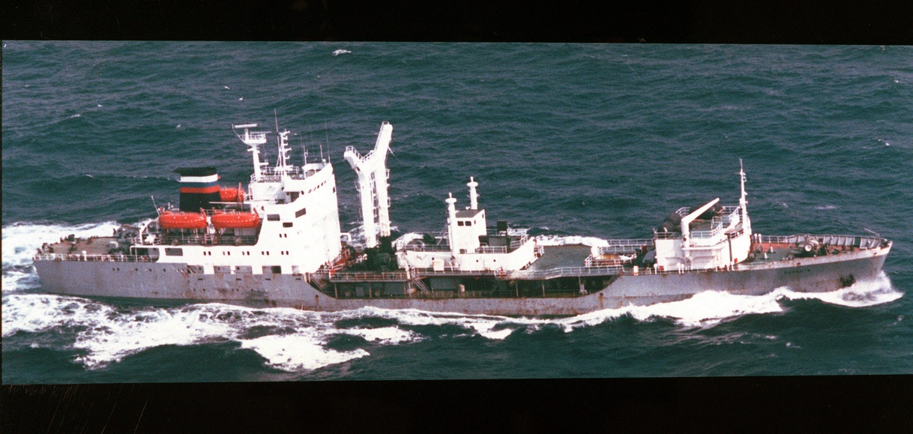

**Polyarnik Class**: Replenishment Tanker – 12,500 tons, the oldest naval tanker in the Soviet fleet and based in the Northern Fleet this ship can refuel from either side simultaneously or astern.

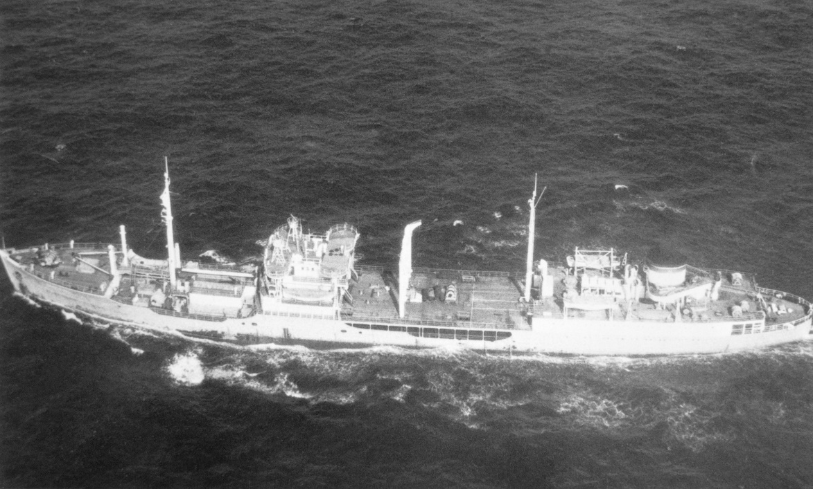

**Project 1818A**: Armament Transport – 1,900 tons, 4 built (Ural, Urmi)

**Project 1821**: Submarine Tender – 3,250 tons, 7 built (PB-34, 47, 68, 75, 98, 124, 125)

**Muna Class**: A widely used class of small ship with between 40 and 50 built in total.

* Pr 1823, 1823B, 1823V: Armament Transport – 5-800 tons, 14+2+4 built: 20 ships total
* Pr 1823R: Refrigerated Transport – 715 tons, 1 built (MRT-148)
* Pr 1823A: Small Transport – 700 tons, several, probably 4-6 built.
* Pr 1824, 1858: Trials ship – 750 tons, 7+1 built: 8 ships total
* Pr 1824B: Small Intelligence Ship (AGI) – 750 tons, 7 built.
* Pr 18236: Border Patrol Ship – 455 tons, 4 built.

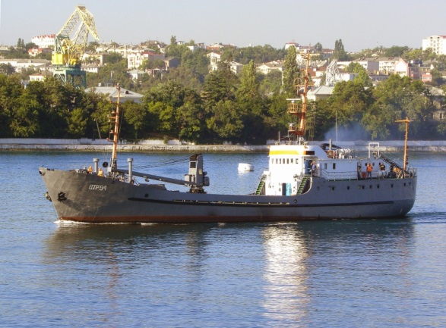

[**Berezina Class Supply Ship**](http://www.ww2.dk/new/navy/berezina.htm): Only one of this class (Project 1833 or 1859) was built as an AOR able to transfer fuel, ammunition, dry goods, rations and other stores to ships off either side simultaneously. Although attached to the Black Sea Fleet this ship saw extensive service in the Atlantic and Mediterranean.

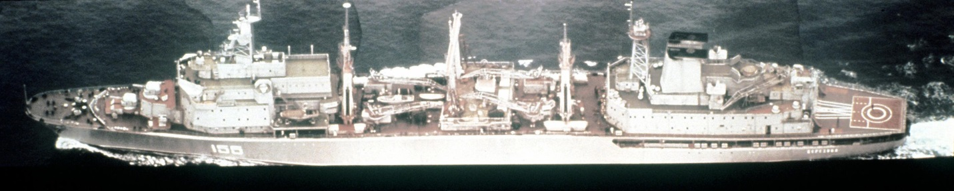

**Toplivo Class**, Project 1844, 18444: Small Tanker – 1,125 tons or 1,300 tons, 44+3 built: 47 ships total, 8 transferred to Egypt, 2 to Yemen, 37 remaining in Soviet service. 7 are water tankers, remainder carry fuel, petrol or oil.

**Project 1849**: Medium Dry Cargo Transport – 2,200 tons, 10 built (Kovda, Tuloma, Onega, Mezen, Ponoy, Eruslan, Ritsa, Tvertsa, Teriberka)

**Ugra Class**, Project 1886: Submarine Tenders – 8,300 tons, 10 built (PB-6, PB-7, PB-20, PB-32, PB-82, Volga, Ivan Vakhrameev, Ivan Kolyshkin, Borodino, Gangut). Volga is the Flagship of the 5th Operational Squadron in the Mediterranean.

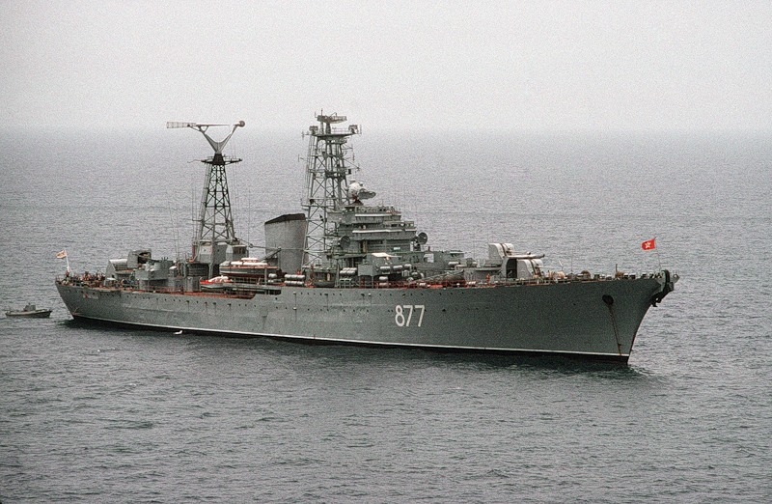

**Nyryat II Class**, Project 1896: Large Hydrographic Survey Boats – 125 Tons, 96 built (GPB-69 up to GPB-1659 with gaps, PSKA-518, KSV-409, UK-231 & 644)

**Malina Class**, Project 2020: Nuclear Fuel Transport – 13,900 tons, 5 built (PTB-5 to 9) all completed.

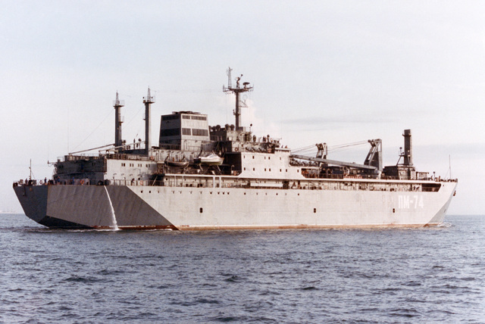

**Olekma Class**, Project 6504: Medium Tanker – 6,500 tons, 3 built (Olekma, Iman, Zolotoy Rog)

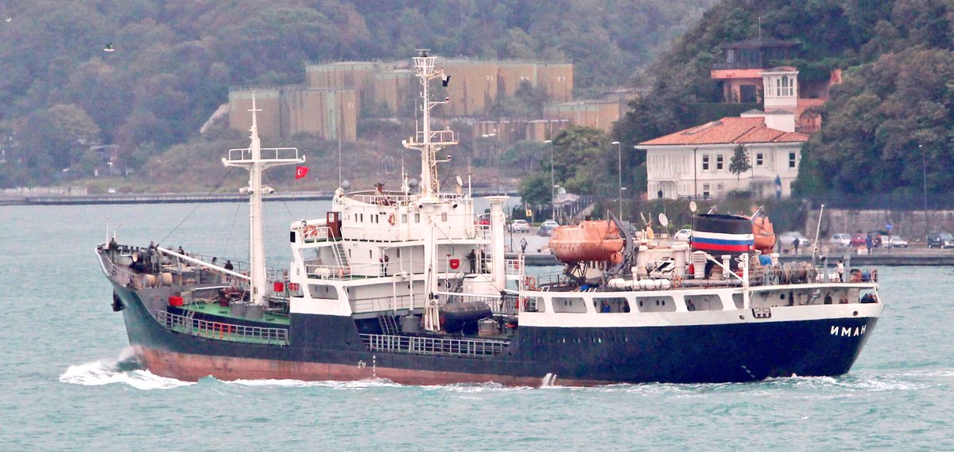

**Aleksandr Brykin**, Project 11570: Armament Transport – 11,450 tons, 2 built (Alexandre Brykin, one other that was historically canceled in 1991).

